Victor Gregory Matos

CSD380-H330  
Professor Sampson

Module 5.2 Assignment

## Hybrid Work Value Stream Mapping

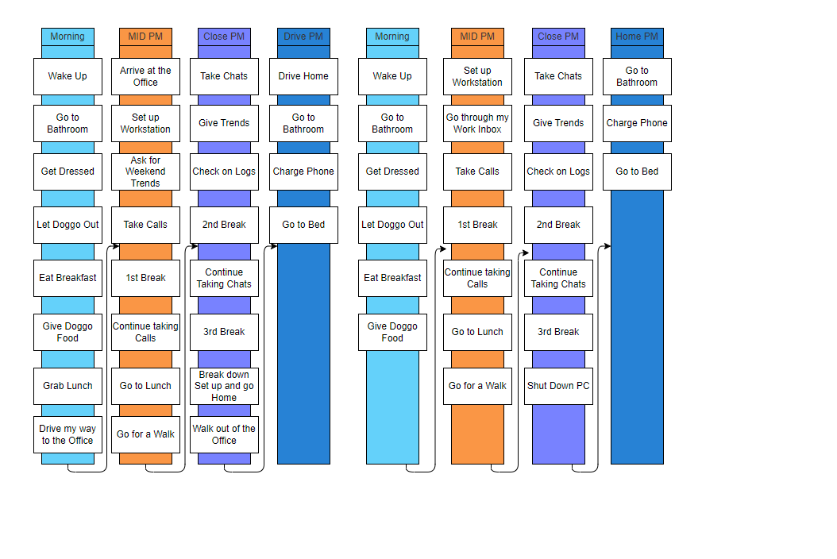

Having a visual representation of your daily schedule really helps identify areas where time can be optimized. By analyzing your routine, you can see where unnecessary delays occur, where tasks can be streamlined, and where you have opportunities to introduce more productive or meaningful activities.

This kind of time analysis allows one to trim inefficiencies, consolidate tasks, and even carve out extra time for things you may have been neglecting, such as skill development, exercise, or personal projects.

## Estimated Average Flow Time

|  |  |
| --- | --- |
|  | **Time** |
| Morning | 2 Hours |
| Mid PM | 5 hours |
| Close PM | 4.5 hours |
| Drive PM | 45 mins to 1 hour |

### Optimizing my Processes

**Eliminating waste –** One area where I can eliminate wasted time is the period I spend lying in bed, mindlessly scrolling through social media platforms like Reddit. While it may feel relaxing in the moment, this habit ultimately consumes valuable time that could be used more productively.

If I replace this with a structured 15-minute session of light exercise, stretching, or even a quick workout, it would not only free up time but also contribute to improving my overall health and energy levels. A short morning movement routine can enhance circulation, reduce stiffness, and help me start my day with more focus and motivation.

Whenever work is slow, I can take advantage of that time to learn new skills or research potential certifications related to technical fields. Instead of idly waiting for tasks, I can use this downtime to develop expertise that could enhance my career prospects.

By dedicating time to learning—whether through online courses, reading industry articles, or practicing coding—I can build valuable knowledge that will strengthen my resume. Certifications in relevant technical skills can also help me stand out to recruiters and open up new career opportunities.

Turning idle time into learning time is a productive way to invest in my future while staying engaged at work.